Collaborative Learning Center

1700 Tribute Road, Suite 100
Sacramento, CA 95815

916-733-6330

From I-5 South, Woodland to Sacramento
Take I-5 South towards Sacramento Take exit 520/Richards Blvd
Turn left onto Richards Blvd Turn left onto CA-160 North
Exit on 47B/Exposition Blvd/Royal Oaks Dr. Continue on Exposition Blvd
Turn right onto Tribute Road
Once on Tribute, follow 0.3 miles to 1700 Tribute Road

From Hwy 50 West, Placerville to Sacramento
Take Hwy 50 West
Take Exit 6C/Bus 80 East/Capital City Freeway toward Reno Take exit 9A/Exposition Blvd West (stay in the left lane) Turn left onto Exposition Blvd
Turn left on Tribute
Once on Tribute, follow 0.3 miles to 1700 Tribute Road

From CA 99 North, Elk Grove to Sacramento

Take CA-99 North toward Sacramento
CA-99 will transition; follow to Bus-80/Capital City Fwy East toward Reno
Take exit 9A/Exposition Blvd West (stay in left lane) Turn left onto Exposition Blvd
Turn left onto Tribute
Once on Tribute, follow 0.3 miles to 1700 Tribute Road

From I-80 West, Roseville to Sacramento

Take I-80 West toward Sacramento
Take Capital City Freeway/Business 80 (exit 95) toward Sacramento and merge onto freeway
Take exit 9A/Exposition Blvd (ramp right) Turn right onto Exposition Blvd
Turn left onto Tribute Road
Once on Tribute, follow 0.3 miles to 1700 Tribute Road

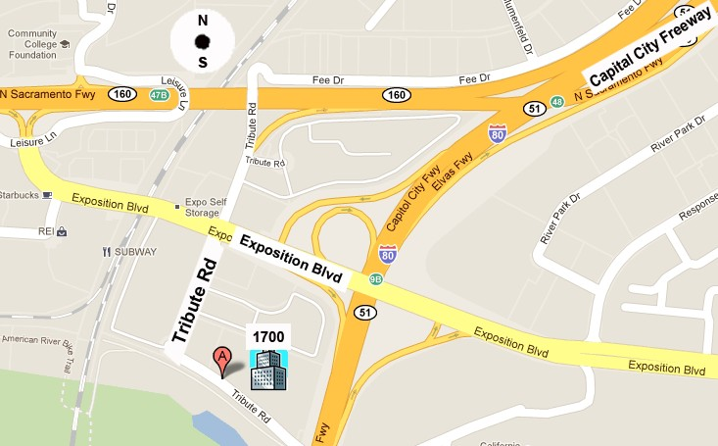

REI/CostCo

Cal Expo

Tribute is located off of Exposition Blvd between REI/Costco and Cal Expo More parking is located in back of the building.
Entrance is on the Tribute Road side.

